Oded Falik

Dr. Karen Mazidi

CS 3340.005

2 December 2018

Project Documentation: MIPS Sudoku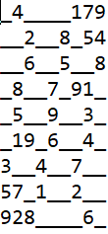

This MIPS program allows users to play sudoku. Given a variety of puzzles of varying difficulties, players can choose which to play. These options are sourced from text files, read through a buffer into the game’s memory, and are formatted properly before being displayed. To run, open project.asm using MARS MIPS Assembler jar file within the same folder as the text files, assemble, and run.

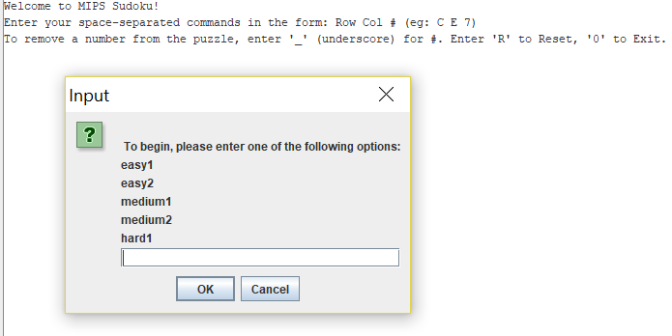

On selection of an option, the game begins. Players input commands using the space-separated format Row Col # (eg. A B 6). Furthermore, values can be erased from the board by inputting an underscore as the #. At any point during a game, players may enter ‘R’ to reset the board, or ‘0’ to exit.

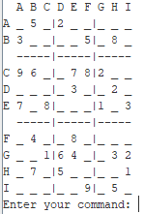

The game provides answer validation for each move. This is done using pointer arithmetic, scanning the row, column, and box of each attempt. On a bad attempt, the following is displayed:

Notice that Row B, Column B has a 5 in the same box, as well as the same row. On a valid move, the board is updated and displayed: 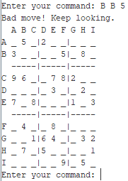

For testing purposes, you may try puzzle ‘debugEndgame,’ which will print as such:

When D D is filled with any number but 1, the end game will be displayed.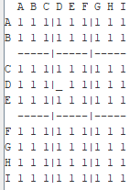

**Happy puzzling!**